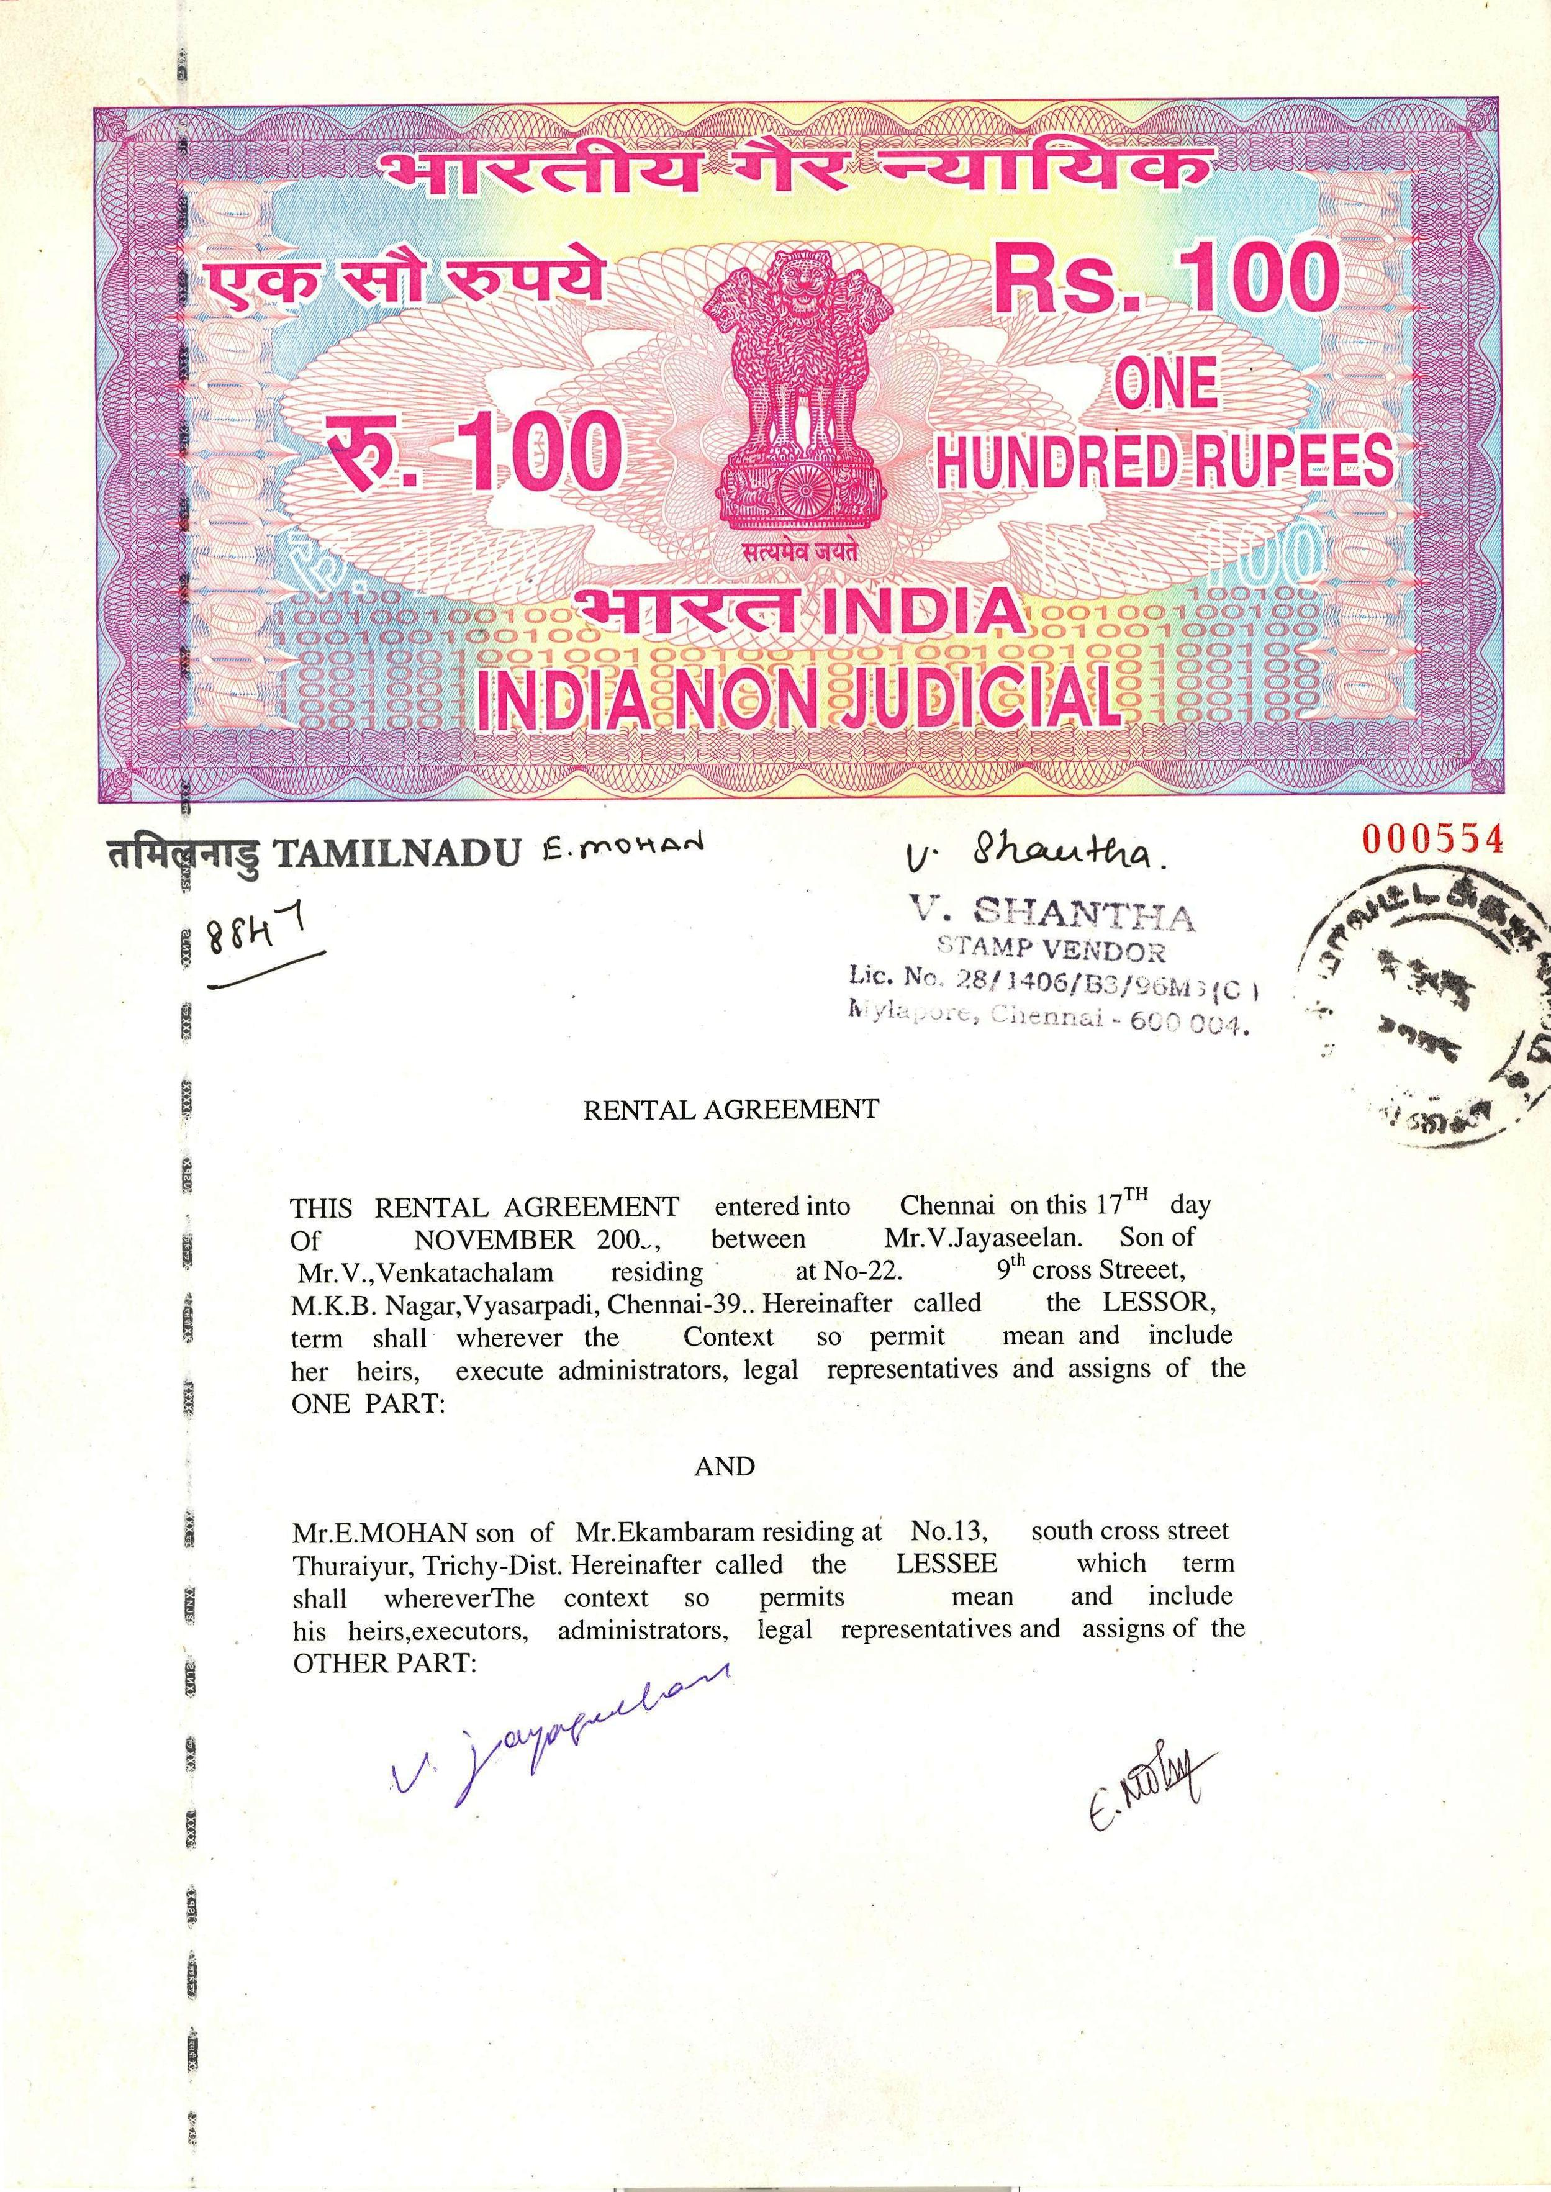

70GS 843218

RENTAL AGREEMENT

This AGREEMENT of rent made on this 2nd April 2018 between Mr. Annadurai D residing at Flat No-7S,SIS Meridian, 100 Feet Road, Velachery, Chennai 600042. Hereinafter called the LESSOR, term shall wherever the Context so permit mean and include his/her heirs, execute administrators, legal representatives and assign of the
ONE PART:
AND
Mrs.Anushya P is the lease holder with right of Sub–Leasing and in possession at Flat No-6Q, SIS Meridian, 100 Feet Road, Velachery, Chennai 600042. Hereinafter called the LESSEE which term shall wherever the Context so permit mean and include his/her heirs, executors, administrators, legal representatives and assigns of the
OTHER PART:



2

2

It is now agreed that the Lessor shall give the Lessees shall take the premises on rent on the following terms and conditions.

- That the term of the lease would be for Twelve months only beginning on 01.04.2018 to 31.03.2019. The contract for tenancy period can be renewed for further period by mutual consent, which of-course will be with the written consent of the Lessor on the terms and conditions to be settled then.
- That the lessees have paid Security Deposit of Rs. 90,000/- (Rupees Ninety Thousand Only) by cash today duly acknowledge by Lessor and which will be returnable at the time of the expiry of the lease agreement, after deducting all the dues, if any from the Lessees including the value of the loss to the amenities and property in the pre mises and which will not carry any interest.
- Monthly rent of Rs. 14000/- (Fourteen Thousand only) per month shall be paid regularly in advance by the Lessees by the fifth of each English Calendar Month.
- The lessor shall pay all taxes including house tax and ground rent as are or hereinafter be assessed on the above premises by the Corporation/MMDA or any local authority.
- This RENTAL is for the Lessee to use the premises only for the purpose of Residential.
- The Lessee will pay for Electricity (Power and Light) and water charges and monthly maintenance charges for building as fixed by the Association according to the bills or meter readings.

3

- The Lessee will carry out day to day repairs such as fuses, leakage of water tapes etc. at their own cost, but major repairs such as leakage in electricity, bursting of sanitary pipes, cracks will be done by the lessor at his cost.
- The tenancy will be terminable on One month’s notice on either side by the Lessor or Lessee and in case the house is vacated without any notice then the Lessee in lieu of vacating the house without notice will pay One month’s rent.
In witness whereof the parties hereto have executed this agreement on the day month and year first herein above mentioned written in the presence of the witnesses mentioned below.

(Annadurai D) (Anushya P)
LESSOR LESSEE

WITNESSES:

1.

2.



